Lecture Notes

Case Study Minimum Wage

Part 1: Theory

Competitive Model

Labor supply

Firm level (ES, pp.41)

Here figure 2.11

Supply of Secretaries to a Firm at Alternative Market Wages

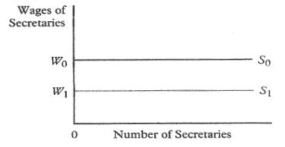

- Firm’s labor supply curve
- Perfectly elastic labor supply
- Firms are wage taker
Intuition: if they pay less, people leave

Market level

Here figure 2.9:

Market Supply Curve for Secretaries

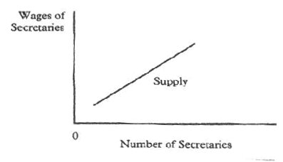

- Market supply curve
- Ceteris paribus clause (wages of others held constant)
- Upward sloping market curve
Intuition: Relative wage increase leads to more people becoming secretaries rather than insurance agents

Remark: wage of insurance agents is a shift parameter
Increase shift market supply curve for secretaries to the left

Labor demand
Mc Kenna/Rees 1992, pp 192

Microfoundation II:
Short run labor demand curve

Optimization of profit function
Assumption: constant C

Derivation of the Marginal Value Product

Intuition for falling labor demand curve

Microfoundation II
E/S PP 91
Long run labor demand curve
Assume profit maximizing output level Q*

Fig. 3A.4

Cost Minimization in the Production of Q*
(Wage = $20 per Hour; Price of a Unit of Capital = $20)

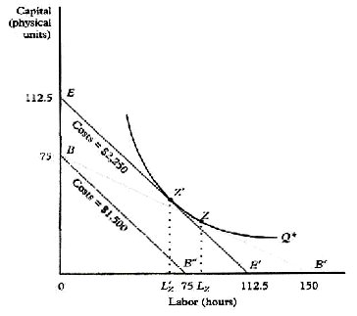

Cost minimization yield optimal combination of C and L
Substitution effect

Scale effect

Fig. 3A.5

The Substitution and Scale Effects of a Wage Increase

Labor demand elasticities
ES pp. 102

- scale effect (short-run): -0.5 (c.p. relation between C and L)
- substitution effect (long-run)
- overall labor demand elasticity: -1

Monopsony

ES pp73
Borjas pp 193

One-company town
Intuition: firm has to increase w to attract workers

Firm level

- upward sloping firm level labor supply curve

Two cases
- perfectly discriminating
B figure 5.16

The hiring decision of a perfectly discriminating monopsonist

- non discriminating
B figure 5.17

The hiring decision of a nondiscriminating monopsonist

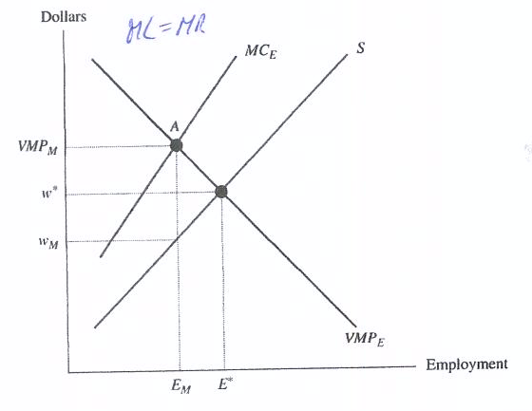

Effect of Minimum Wage

B figure 5.18

The impact of the minimum wage on a nondiscriminating monopsonist

Conclusion:
Higher wages could result in higher employment depending on the level of the minimum wage

Hint:
Be careful and do not mix up
- reason for the upward sloping labor supply curve (intuition: firms have to pay more to attract workers)
- reason for lower wages for workers in the non-discrimating case (intuition: firms pay less than MR: firms exploit workers)
Note: In case of a discrimination monopsony workers are paid according to their reservation wage. Discrimination could be a good thing like price discrimination (which is the reason why you get your US textbooks cheaper than your colleagues in the US)
Search Theory

Equilibrium Search Model
Pissarides/Mortensen (Monopsony in Motion)

B pp487
C/Z Chap. 3 pp. 127 and Ch.12.1

Basic idea
- people maximize dynamically (Hamiltonian)
- discount rate
- wage offer distribution
- search costs
- search strategies (non-sequential and sequential)
- reservation wage
- unlike partial model: endogenous distribution of wages (strategic behavior of firms is integrated)
- 5 advantages (C/Z, pp. 131): pretty realistic, just one major flaw

Main message for our purposes
Employer may realize a monopsony position
If a) search costs
- mobility costs (Jobwechselkosten)
are high

Matching Model

C/Z Ch. 9 and 12.1
Blanchard/Diamond 1994
Analytical foundation for the Beveridge curve

- flow approach
- transaction costs
- hiring and firing costs
- job creation
- job destruction

Matching model with endogenous labor market participation and job search effort
Provide further arguments for minimum wages

- participation may increase employment
- higher job search effort may increase employment

Effect of Minimum wage
Calibration (pp. 727)

Other Models

More realistic reasons for upward sloping firm level labor supply curve:
Monitoring costs of larger firms – pay more to reduce shirking
Part 2: Empirical Analysis

„Microsimulation“

ifo-institut
Ragnitz/Thum 2007
Ragnitz/Thum 2008, Abb. 3 p. 65

Labor demand elasticity –0.75

Assumptions:
Iso-elastic labor demand curve
Competitive model

Minimum wage 7.5 € reduces employment by 1.1 million
800.000 West Germany
300.000 East Germany

even with 4.5 €
-360.000 employed

Conclusion:
There is no alternative to these results given the chosen model. However, theory and empirical approach is due to the early 90s. It ignores theoretical progress and empirical research of more than one decade.

Natural experiment

C/Z, p. 41 with application
Wooldridge, pp. 129
Best Caliendo
The seminal study of Card/Krueger 1994 and CK 2000
Results hold even with administrative data
See Tutorial

Approach (Summary C/Z p. 730)
- selection on unobservable assumption
- Diff in Diff
- Survey data (1994)
- Administrative data (2000)

Data
Individual longitudinal data

Advantages
Removes biases associated with a common time trend unrelated to the intervention (Athey, Imbens 2006)
Elimination of fixed individual effects

Identifying assumption
Time-invariant linear selection effects i.e. biases are the same on average in different time periods before and after the period of participation in the programme so that differencing the differences eliminates the biases

However, if selection effect varies over time or is non-linear, DID is not identified

Ashenfelter’s dip is problem for this estimator

Estimator in practice:

OLS estimator with interpretation of dummy variable regression coefficient as DID estimator
Formally follow C/T p. 56

Critique
- Groups have to remain comparable over time
- policy change may not be driven by other factor hidden in the error term

New development
- Non-linear DID (Athey/Imbens 2006)

German natural experiment: Minimum wages in the construction sector

König/Möller 2007

Exogenous variation
Introduction of a minimum wage in the construction sector 1997
Treatment group: employees before introduction who earned less than the m.w.
Control group: employees in the same sector who earned more than the m.w. before introduction

Result:
West Germany: no significant negative employment effect
East Germany: significant negative employment effect

Same methodology like Machin et al. (2003)

Critique:
- shadow economy/moonlighting ignored
- other behavorial responses (work more hours) not measured
- Schmidt/Kluve 2008 (Handelsblatt): control group was also affected by treatment due to substitution. Hence the study is not credible.
- Fitzenberger 2008: argument is right in principle but irrelevant for the results of K/M 2007 (details do not play a role for our purposes)

Conclusion:
Results are a methodological progress for German empirical results

Overall conclusion:
No clear evidence that a low minimum wage, e.g. 5 € per hour, really destroys employment opportunities

Maybe job search efforts would increase
Maybe wages would be perceived as fair wages
Maybe wage inequality (other policy goal) would not increase as much as in the counterfactual state
Maybe fiscal savings would occur due to lower unemployment benefit II expenditures
Maybe Pandorra’s box will be predominant
Maybe we need a neutral institution such Low Pay Commission to avoid Pandorra’s box

We better discuss low minimum wages on a serious theoretical and empirical level rather than destroying an important discussion by results based on crude and old fashioned methods

However: a high minimum wage would certainly destroy employment opportunities!! Be cautious with this topic

Literature:

Ehrenberg/Smith (2003), Modern Labor Economics, 8th edition, Addison Wesley
Borjas (2005), Labor Economics, 3rd edition, Mc Graw Hill
Cahuc/Zylberberg (2004), Labor Economics, MIT Press
Wooldridge (2002), Econometic Analysis of Cross Section and Panel Data
Cameron/Trivedi (2005), Microeconometrics, Cambridge

German Minimum Wage discussion:
Fitzenberger (2008)
Schmidt/Kluve (2008)
König/Möller (2007)
Franz (2008)

